AI ASSISTED CODING
ROLLNO:2403A52096
BATCH:04
LABTEST-04
SET-07
TASK1:
PROMPT: Design a database schema for a Fitness Tracking App and write an SQL query to calculate daily calorie burn.
CODE:
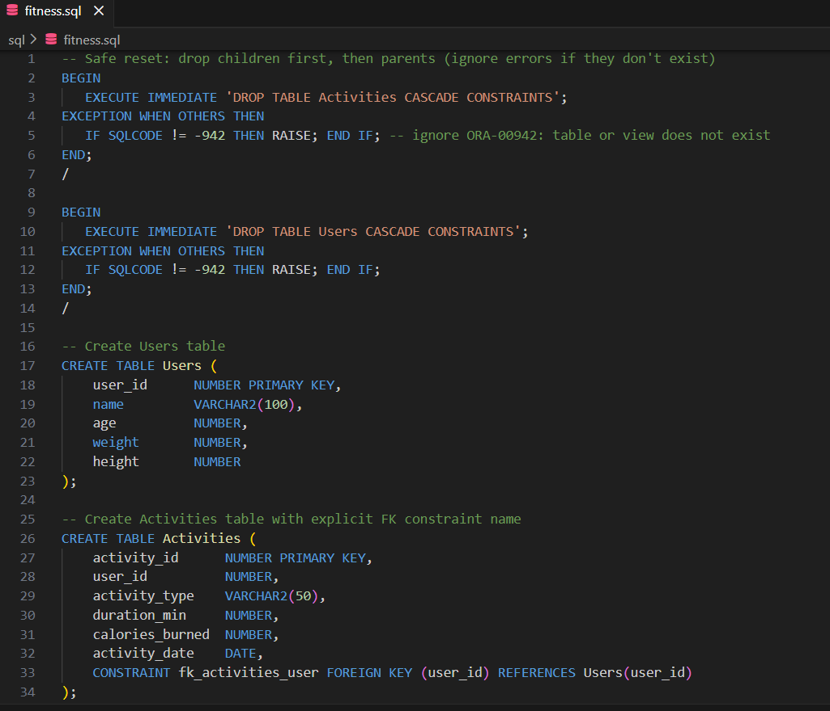
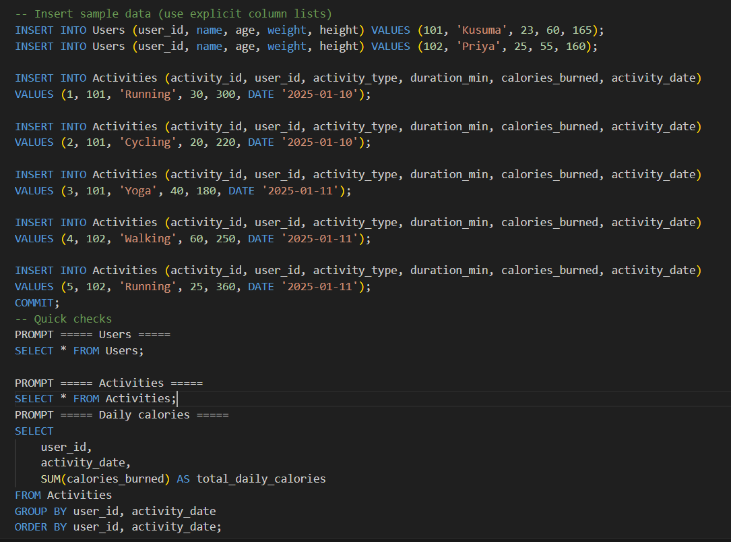
OUTPUT:
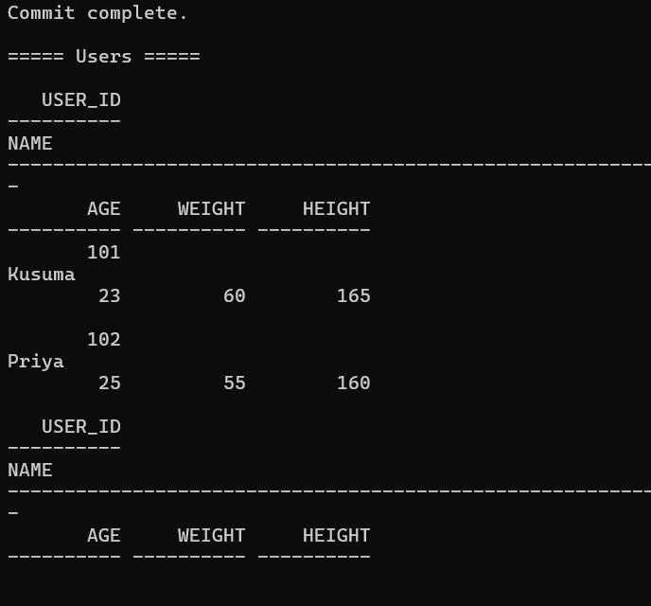
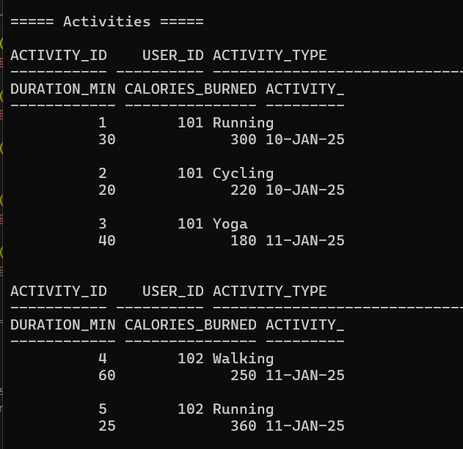
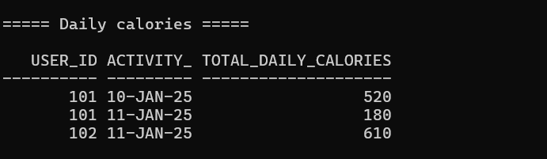

OBSERVATION:
The query correctly aggregates calories burned per user per day by multiplying workout duration with calories-per-minute for each activity and summing them. This helps track daily fitness progress and identify trends in calorie expenditure.
TASK2:
PROMPT: Clean heart-rate CSV logs by removing missing/invalid values, then generate rolling averages using AI-assisted code suggestions.
CODE:
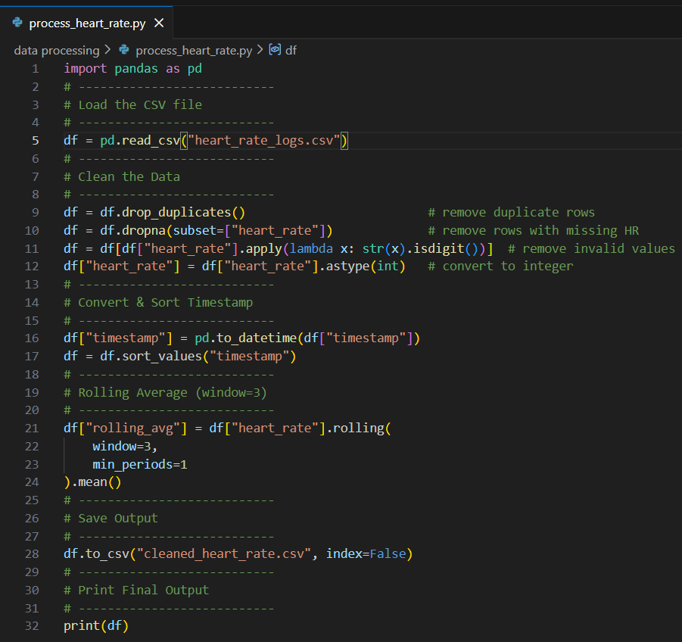
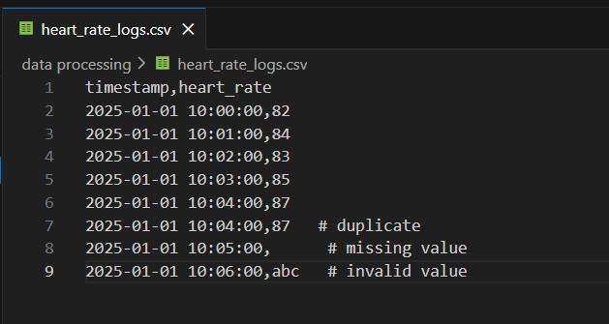
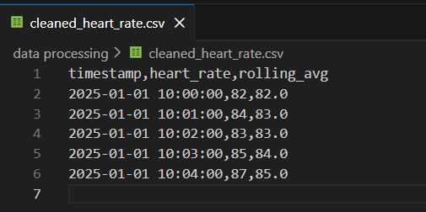
OUTPUT:
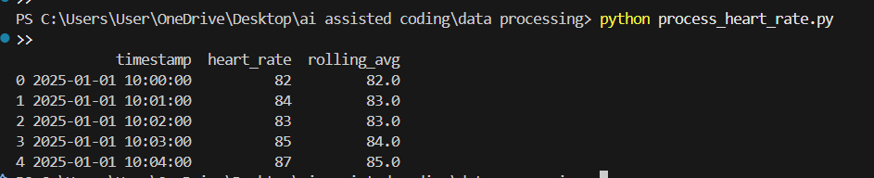

OBSERVATION:
After cleaning the CSV logs, invalid and noisy data points are removed, making the dataset reliable. The rolling averages smooth out fluctuations and provide a clearer trend of heart-rate behavior over time, helping detect abnormal spikes or patterns.

